RVS COLLEGE OF ENGINEERING AND TECHNOLOGY
COIMBATORE-641 402
IBM NALAYA THIRAN
PROJECT REPORT
Team ID | PNT2022TMID42904
Project Name | Project – IOT ENABLED SMART FARMING APPLICATION
TEAM LEAD : ARJUN.S
TEAM MEMBER 1: HARIHARAN.R
TEAM MEMBER 2: DHAYANANTH.E
TEAM MEMBER 3: GOKUL.R
MENTOR : VALLISUSEELA R
- INTRODUCTION
  - Project Overview
  - Purpose
- LITERATURE SURVEY
  - Existing problem
  - References
  - Problem Statement Definition
- IDEATION & PROPOSED SOLUTION
  - Empathy Map Canvas
  - Ideation & Brainstorming
  - Proposed Solution
  - Problem Solution fit
- REQUIREMENT ANALYSIS
  - Functional requirement
  - Non-Functional requirements
- PROJECT DESIGN
  - Data Flow Diagrams
  - Solution & Technical Architecture
  - User Stories
- PROJECT PLANNING & SCHEDULING
  - Sprint Planning & Estimation
  - Sprint Delivery Schedule
  - Reports from JIRA
- CODING & SOLUTIONING (Explain the features added in the project along with code)
  - Feature 1
  - Feature 2
  - Database Schema (if Applicable)
- TESTING
  - Test Cases
  - User Acceptance Testing
- RESULTS
  - Performance Metrics
- ADVANTAGES & DISADVANTAGES
- CONCLUSION
- FUTURE SCOPE
- APPENDIX
Source Code
GitHub & Project Demo Link

1.INTRODUCTION
IOT- internet of things:-
The Internet of things (IoT) describes physical objects (or groups of such objects) with sensors. processing ability, software and other technologies that connect and exchange data with other devices and systems over the Internet or other communications networks.Internet of things has been considered a misnomer because devices do not need to be connected to the public internet, they only need to be connected to a network and be individually addressable.
The field has evolved due to the convergence of multiple technologies, including ubiquitous computing, commodity sensors, increasingly powerful embedded systems, as well as machine learning. Traditional fields of embedded systems, wireless sensor networks, control systems, automation(including home and building automation), independently and collectively enable the Internet of things. In the consumer market, IoT technology is most synonymous with products pertaining to the concept of the "smart home", including devices and appliances(such as lighting fixtures, thermostats, home security systems, cameras, and other home appliances) that support one or more common ecosystems, and can be controlled via devices associated with that ecosystem, such as smartphones and smart speakers. IoT is also used in healthcare systems.
There are a number of concerns about the risks in the growth of IoT technologies and products, especially in the areas of privacy and security, and consequently, industry and governmental moves to address these concerns have begun, including the development of international and local standards, guidelines, and regulatory frameworks.
1.1 PROJECT OVERVIEW:-
This project is based on Iot enabed smart farming application which rates to be retained and preferred to be conditional based full automation of the prospects and retained to reduce the work for the farmers who were considered as the backbone of our society. In order to achive this we use a trending technology named as Iot thus it is applying the concept of Iot and retesion ancient farming irrigation methods and using aurdino UNO and progressing the smart irrigation by making the smart automation this tends to be known as smart irrigation process.

1.2PURPOSE :-
The main purpose of reducing the smart farming application using the aurdino UNO is to make an sealed cut down of human interference in the process of irrigation due to this irrigation process becomes simple and easy for farmers.
2.LITRATURE SURVEY:-
  - Existing problem
PROBLEM STATEMENT :
To incorporate the process of working and also elevate the smart farming using IOT enabled smart irrigation technique since the traditional irrigation technique which is very complex one.
  - References:-
https://ieeexplore.ieee.org/document/9432085
1.
S.K.. Luthra, "Design and development of an auto irrigation system", Agricultural Water Management, 1997.
Show in Context CrossRef Google Scholar
2.
Suhinthan Maheswararajah, Saman K. Halgamuge, Kithsiri B. Dassanayake and David Chapman, "Management of Orphaned-Nodes in Wireless Sensor Networks for Smart Irrigation Systems", IEEE Transactions on Signal Processing, 2011.
Show in Context View Article
Google Scholar
3.
Joaquín Gutiérrez, Juan Francisco Villa-Medina, Alejandra Nieto-Garibay and Miguel Angel, "Port a-Gandara Proposed a Automated Irrigation System Using a Wireless Sensor Network and GPRS Module", IEEE Transactions on instrumentation and measurement, 2013.
Show in Context Google Scholar
4.
M Chetan Dwarkani, R Ganesh Ram, S Jagannathan and R. Priyatharshini, "Smart farming system using sensors for agricultural task automation", 2015 IEEE Technological Innovation in ICT for Agriculture and Rural Development (TIAR), 2015.
Show in Context View Article
Google Scholar
5.
G. Shruthi, B. Selva Kumari, R. PushpaRani and R. Preyadharan, "A-real time smart sprinkler irrigation control system", 2017 IEEE International Conference on Electrical Instrumentation and Communication Engineering (ICEICE), 2017.
Show in Context View Article
Google Scholar
6.
Dwarkani M Chetan, Ram R Ganesh, S Jagannathan and R. Priyatharshini, "Smart farming system using sensors for agricultural task automation", 2015 IEEE Technological Innovation in ICT for Agriculture and Rural Development (TIAR), 2015.
View Article
Google Scholar
7.
Abubakr Muhammad, Bilal Haiderb and Zahoor Ahmad, "Proposed a IoT Enabled Analysis of Irrigation Rosters in the Indus Basin Irrigation System", 12th International Conference on Hydro informatics HIC, 2016.
Google Scholar
8.
G. Shruthi, B. Selva Kumari, R. Pushpa Rani and R. Preyadharan, "A-real time smart sprinkler irrigation control system", 2017 IEEE International Conference on Electrical Instrumentation and Communication Engineering (ICEICE), 2017.
View Article
Google Scholar
9.
Mehdi Roopaei, Paul Rad and Kim-Kwang Raymond Choo, "Cloud of Things in Smart Agriculture: Intelligent Irrigation Monitoring by Thermal Imaging", The University of Texas at San Antonio IEEE cloud computing, january/february 2017.
View Article
Google Scholar
10.
J. JegatheshAmalraj, S. Banumathi and J. JereenaJohn, "A Study On Smart Irrigation Systems For Agriculture Using Iot", International Journal Of Scientific & Technology Research, vol. 8, no. 12, December 2019.
Show in Context Google Scholar
11.
Laura Garcia, Lorena Parra, Jose M. Jimenez, Jaime Lloret and Pascal Lorenz, "IoT -Based Smart Irrigation Systems: An Overview on the Recent Trends on Sensors and IoT Systems for Irrigation in Precision Agriculture", Sesnors, 2020.
Show in Context CrossRef Google Scholar
12.
I.D. Ighodaro, A. Mushunje, B.F. Lewul and B.E. Omoruvi, "Climate-Smart Agriculture and Smallholder Farmers' Income: The Case of Soil Conservation Practice-Adoption at Qamata Irrigation Scheme South Africa", JHE, 2020.
Show in Context CrossRef Google Scholar
13.
Akey Sungheetha and Rajesh Sharma, "Real Time Monitoring and Fire Detection using Internet of Things and Cloud based Drones", Journal of Soft Computing Paradigm (JSCP), vol. 2, no. 03, pp. 168-174, 2020.
Show in Context CrossRef Google Scholar
14.
J. Arumai Ruban, C. Balakrishnan and S. Santhoshkumar, "G. Jagan Study of Smart Farming Techniques in Drip Irrigation using IoT", International Journal of Advanced Science and Technology, vol. 29, no. 2, pp. 4595-4613, 2020.
Show in Context Google Scholar
15.
S. Velmurugan, V. Balaji, T. Manoj Bharathi and K. Saravanan, "An IOT based Smart Irrigation System using Soil Moisture and Weather Prediction", International Journal of Engineering Research & Technology (IJERT), ISSN 2278-0181.

  - PROBLEM STATEMENT EXPLANATION:-
IOT plays a major role in agricultural field This paper is mainly applied to agricultural field Smart irrigation and farming can help farmers to grow healthy plants. The existing system only checks the soil water stress and automates the process of watering. The paper is about IOT based smart farming and irrigation system. The ultimate agenda of this paper is to automate the process of watering to plants. This work helps us to know the values of various parameters such as humidity, moisture and temperature of plants and water them accordingly. The system consists of three sensors which sense the values of humidity, moisture and temperature of plants. If any of the values decreases the motor automatically turns on the water for plants. This is done using Arduino board, voltage regulator and relay which controls the motor. WIFI module is used to inform the user about the exact field condition. The various sensors send the values to the Arduino board which has been coded with if else conditions will further pass the commands to the relay which turns on or off the motor according to the conditions given. If the sensor values are decreased, it turns on the motor else it turns off the motor. The ultimate significance of this paper is that most of the manual work is reduced and watering process is automated with the help of devices as a result of which healthy plants can be grown, Water and electricity usage are saved by this paper. Even elderly people can easily do farming. The paper has been used to grow a tomato plant and it was successfully grown by automatic process. This methodology with the use of IOT technology had made us achieve a healthy farming. Increase in agriculture also helps us to increase the economical state of the country.

IDEATION AND PROPOSED SOLUTION:-
3.1 EMPATHY MAP:-

3.2 IDEATION AND BRAINSTROMING:-
Team Ideas:
Navaneethan R:
Automate irrigation process using temperature of soil.
Automate irrigation using measurement of moisture of soil

Naveenkumar V:-
We can use sensors on sensing
We can sense and program the moisture level

Kavinkumar P:-
We can simplify the drip irrigation into time controlled irrigation
Automate irrigation using any Robots

Parthipan G
We can automate and design Audino for programming
We can make good design and programming of soil moisture and temperature

Best Three Ideas:-
- Automate irrigation using measurement of moisture of soil
➢ We can sense and program the moisture level
- We can automate and design Audino for programming

3.3 PROPOSED SOLUTION:-

Proposed Solution Template:
Project team shall fill the following information in proposed solution template.
S.No. |  | Parameter | Description
1. |  | Problem Statement (Problem to be solved) | To incorporate the process of working and also elevate the smart farming using IOT enabled smart irrigation technique since the traditional irrigation technique I very complex one.
2. |  | Idea / Solution description | To automate irrigation in accordance to the amount of moisture present in soil
3. |  | Novelty / Uniqueness | Automation of irrigation to amount of moisture
4. |  | Social Impact / Customer Satisfaction | The problems faced by the farmers in the process of irrigation gets solved and this full fills and saves their crops from over irrigation
5. |  | Business Model (Revenue Model) | The process of fulfilling this process brings revolution in drip irrigation systems also makes a revolutionary change in market
6. |  | Scalability of the Solution | The design scale of solution has been planned in a compact manner
3.4 PROBLEM SOLUTION FIT:-

 | 6.Customer constrains:-  The customer wants a device which could solve the problems in irrigation when he is remote or absence of humans and that device should fulfill all the following constrains  • cost efficient  • space efficient  • time efficient  • resource efficient
  1.Customer segments:-
  the customers who are going to adapt this project contains of
  • large scale farmers
  • remote farmers
  5.Available solutions
  The moisture controlled irrigation system could be the best solution for this problem statement that has been provided by the farmers and also it specifically satisfies the customer constrains also
  2.Jobs to be done :-
  the customers want to automate the process of irrigation in cost, energy and reduced power consumption and also reliable manner
  9.Problem route cause:-
  The problem has its route stabled at the rate of the fast moving world since people move most of the times and since they have their work to be stagnated similarly farmers face the inability in the process of irrigation
  7.Behavior:-
  The customer wants to make the revolutionary propagation in the rating of the irrigation through the reliability of amount of water availability on the land

 | 8.Channels of behavior:-  • The channels of behavior recombines the ration of the following  • Online  • offline
  3.Triggers:-
  The reliability and easy accessibility of this finished projects yields the peoples attraction have this project installed in their fields
10.Solution:-
Our solution for this project is to initiate the reliability of the irrigation system using the sensor sensed information from the field and also make the automation is on and off of water pump

4.REQUIREMENT ANALYSIS
4.1Functional requirement
Following are the functional requirements of the proposed solution.

 | Sub requirement
 | FR No. |  | Functional requirement
 | FR-1 |  | IoT devices |  |  | Sensors and Wifi module.
 | FR-2 |  | Software |  |  | Web UI, Node-red, IBM Watson, MIT app
 | FR-3 |  | Aurdino |  |  | connectors

4.2Non-Functional requirements

FR No. |  | Non-Functional Requirement |  | Description
NFR-1 |  | Usability |  | Time consumability is less, Productivity is high.
NFR-2 |  | Security |  | It has low level of security features due to integration of sensor data.
NFR-3 |  | Reliability |  | Accuracy of data and hence it is Reliable.
NFR-4 |  | Performance |  | Performance is high and highly productive.
NFR-5 |  | Availability |  | With permitted network connectivity the application is accessible
NFR-6 |  | Scalability |  | It is perfectly scalable many new constraints can be  added

5.PROJECT DESIGN
  - Data Flow Diagrams
5.2 Solution & Technical Architecture

5.3User Stories

6. PROJECT PLANNING & SCHEDULING
6.1Sprint Planning & Estimation

Sprint | Functional Requirement (Epic) | User Story Number | User Story / Task | Story Points | Priority | Team Members
Sprint-1 | Requirement enable | USN-1 | As a user, I can register the problem | 2 | High | Parthipan G  Kavinkumar P
 |  |  | that I have faced |  |  | Parthipan G  Kavinkumar P
Sprint-1 | Analyze the process | USN-2 | As a user, I will receive confirmation and assess of the progression | 1 | High | Navaneethan R  Naveenkumar V
Sprint-2 | Sensor analysis | USN-3 | As a user, I care and analysis of the sight | 2 | Low | Parthipan G  Kavinkumar P
Sprint-1 | Infrastructure development | USN-4 | As a user, I can register for the application through | 2 | Medium | Navaneethan R  Naveenkumar V
 |  |  | Gmail |  |  | Navaneethan R  Naveenkumar V
Sprint-1 | Deployment of module on the field | USN-5 | As a user, I can check that the process is working or not | 1 | High | Kavinkumar P  Navaneethan R  Naveenkumar V  Parthipan G

  - Sprint Delivery Schedule

Sprint | Total Story Points | Duration | Sprint Start Date | Sprint End Date (Planned) | Story Points Completed (as on Planned End | Sprint Release Date (Actual)
 |  |  |  |  | Date)
Sprint-1 | 20 | 6 Days | 24 Oct 2022 | 29 Oct 2022 | 20 | 29 Oct 2022
Sprint-2 | 20 | 6 Days | 31 Oct 2022 | 05 Nov 2022 | 20 | 05 Nov 2022
Sprint-3 | 20 | 6 Days | 07 Nov 2022 | 12 Nov 2022 | 20 | 12 Nov 2022
Sprint-4 | 20 | 6 Days | 14 Nov 2022 | 19 Nov 2022 | 20 | 19 Nov 2022

7.CODING & SOLUTIONING (Explain the features added in the project along with code)
7.1Feature 1
//Arduino Code
// code starts here
int sensor_pin = A0; // Soil Sensor input at Analog PIN A0
int output_value ;
void setup() {
// put your setup code here, to run once:
pinMode(4,OUTPUT);
Serial.begin(9600);
Serial.println("Reading From the Sensor ...");
delay(2000);
}
// put your main code here, to run repeatedly:

void loop() {
output_value= analogRead(sensor_pin);
output_value = map(output_value,550,10,0,100);
Serial.print("Mositure : ");
Serial.print(output_value);
Serial.println("%");
if(output_value<0){
digitalWrite(4,HIGH);
}
else{
digitalWrite(4,LOW);
}
delay(1000);
}
//Code ends here

  - Feature 2:-
/*
Plant Watering Sytem

The circuit:
- Water pump
Power supply: 4.5~12V DC Interface: Brown +; Blue -
- Temperature/moisture sensor Power supply: 3.3-5v
- Moisture sensor Power supply: 3.3-5v
*/

#include "DHT.h"
#define DHTPIN 2 // what digital pin we're connected to #define DHTTYPE DHT22 // DHT 22 (AM2302), AM2321

DHT dht(DHTPIN, DHTTYPE);

const int SOIL_MOISTURE_SENSOR_PIN = A0; const int WATER_PUMP_PIN = 4;

const int dry = 520; const int wet = 270;
const int moistureLevels = (dry - wet) / 3;

// TODO: Should we have a counter so if it waters for X times, then take a break?
// OPTIMIZE: how dry to start watering and for how long. const int soilMoistureSartWatering = 400;
const int soilMoistureStopWatering = 300;
// 60 seconds
const long waterDuration = 1000L * 60L;
// 60 seconds
const long sensorReadIntervals = 1000L * 60L;
// 2 hr
const long waterIntervals = 1000L * 60L * 60L * 2; long lastWaterTime = -waterIntervals - 1;
boolean isWatering = false;

void setup()
{ Serial.begin(9600); pinMode(WATER_PUMP_PIN, OUTPUT);
waterPumpOff(); dht.begin();

}

void loop()
{ mainLoop ();
}

void mainLoop() {
float temperature = getTemperature(); float humidity = getHumidity();
long soilMoisture = analogRead(SOIL_MOISTURE_SENSOR_PIN);
Serial.println("Soil Moisture: " + readableSoilMoisture(soilMoisture) + ", " + soilMoisture);
Serial.println("Temperature: " + String(temperature) + " *F");Serial.println("Humidity: " + String(humidity) + " %");

if (millis() - lastWaterTime > waterIntervals)
{waterPlants(soilMoisture); lastWaterTime = millis();
}

delay(sensorReadIntervals);
}

void waterPlants(int soilMoisture) {
// Should this take a moving avg of the soilMoisture?
// Can get outliers on the right after watering. if (soilMoisture > soilMoistureSartWatering)
{ isWatering = true
- TESTING
8.1Test Cases:-
INTERFACING OF SENSOR AND AURDINO AND INSTALLATION IN SOIL
According to our project we are improving an automated irrigation system which works in the soil in accordance to the humidity conditions in order to reduce human interference in the process of irrigation
This sprint three is the progression phase of the project in which we feed the code which has been developed for aurdino and we install moisture sensor to the aurino UNO by that we interface both in a successful manner then we install that into the real soil and test in the real time conditions.

PHOTO OF THE INTERFACED AURDINO AND SIL TESTING CONDITION AFTER INTERFACING:-
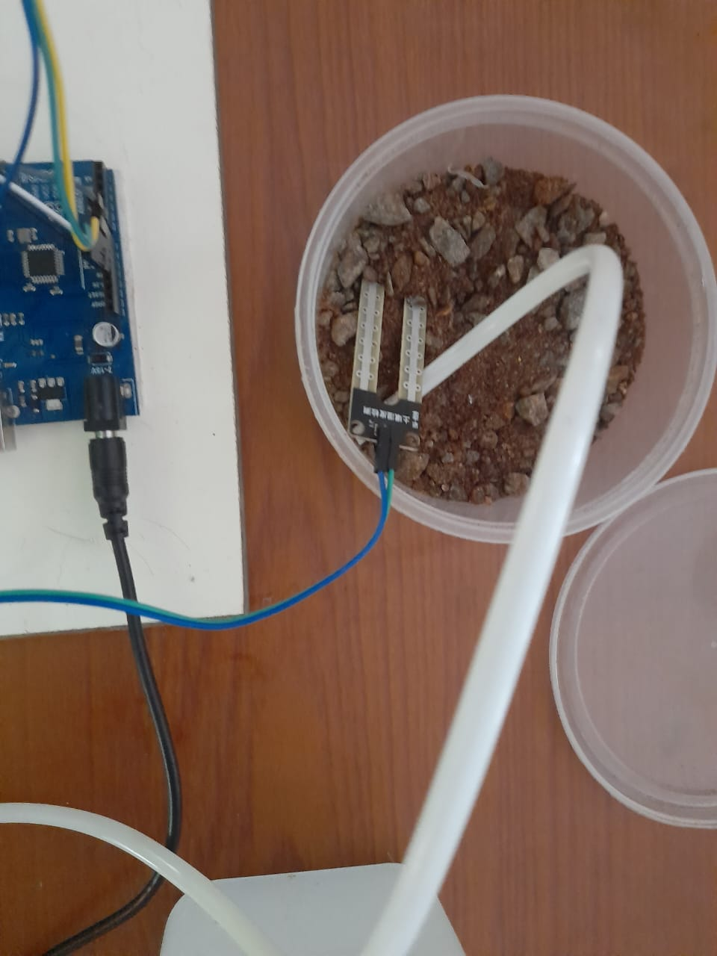

8.2 User Acceptance Testing
INTERFACING AND TESTING AND DELIVERY:-
According to our project we are improving an automated irrigation system which works in the soil in accordance to the humidity conditions in order to reduce human interference in the process of irrigation
Finally we are yet to test our Iot enabled smart farming application and we are yet to test it in the real time environmental conditions in order to make it available for the real time use which could be to solve the problems in irrigation .
In this process we are yet to interface aurdino and configure it, then next to that we are tending to develop a code for the sensor and then we are interfacing it to make the sensing part next to that we are yet to stuff out the water tank and the motor for the irrigation purpose next to that we are going to progress into working conditions with the motor and fix it to the switch which is interfaced to the aurdino then finally the sensor senses the water moisture level in the land and then when the moisture level goes down the switch is switched on by that the motor starts running then the water is sucked out from the water reserve and irrigated to the land abide this when there is enough moisture in land the switch is automatically switched off.
By this we have limbed to our goal of automated irrigation

IMAGE OF FINAL TESTING
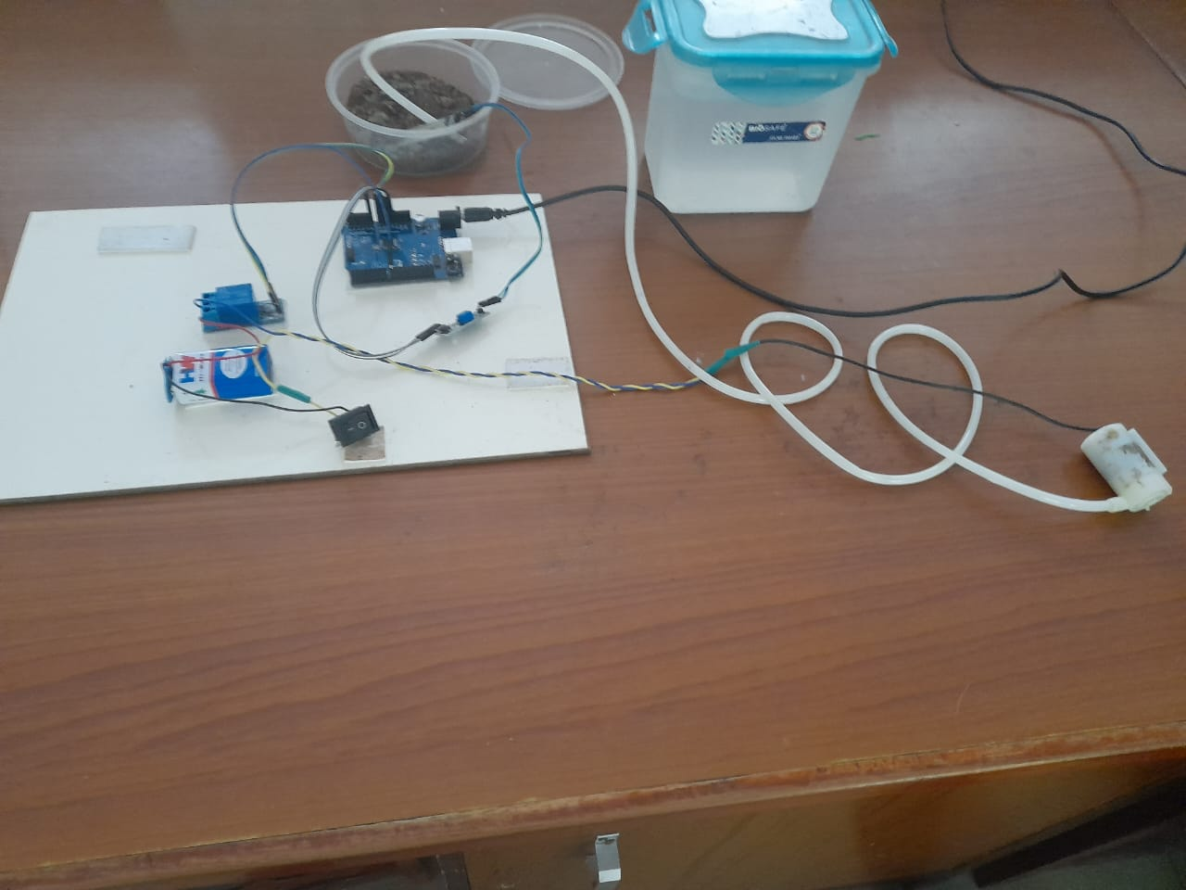
- RESULTS
9.1Performance Metrics:-
Performance matrices | Condition output
Human interference cut down | good
Reduction of wastage | good
Economical efficiency | better
Reliability | excellent

10.Advantages and Disadvantages:-
Advantage:-
- The user can be remote at any time
- The user interference is not required
- Reduces over irrigation
- Reliability is high
- Enhances the process of irrigation
- Reduce wastage of resources
- Improves lifestyle of farmers
- Makes the progression to be easy
- Improves ground water level in a periodical manner
- Improved yield for farmers.
- Attracts most of the people to involve in agriculture
- Since the agriculture improves, human life also improves
Disadvantages:-
- work for the people is reduced
- sensors and the components should be maintained
- there may be a threat of damaging sensors by animals present in the field
11.conclusion:-

To incorporate the process of working and also elevate the smart farming using IOT enabled smart irrigation technique since the traditional irrigation technique which is very complex one.
IOT plays a major role in agricultural field This paper is mainly applied to agricultural field Smart irrigation and farming can help farmers to grow healthy plants. The existing system only checks the soil water stress and automates the process of watering. The paper is about IOT based smart farming and irrigation system. The ultimate agenda of this paper is to automate the process of watering to plants. This work helps us to know the values of various parameters such as humidity, moisture and temperature of plants and water them accordingly. The system consists of three sensors which sense the values of humidity, moisture and temperature of plants. If any of the values decreases the motor automatically turns on the water for plants. This is done using Arduino board, voltage regulator and relay which controls the motor. WIFI module is used to inform the user about the exact field condition. The various sensors send the values to the Arduino board which has been coded with if else conditions will further pass the commands to the relay which turns on or off the motor according to the conditions given. If the sensor values are decreased, it turns on the motor else it turns off the motor. The ultimate significance of this paper is that most of the manual work is reduced and watering process is automated with the help of devices as a result of which healthy plants can be grown, Water and electricity usage are saved by this paper. Even elderly people can easily do farming. The paper has been used to grow a tomato plant and it was successfully grown by automatic process. This methodology with the use of IOT technology had made us achieve a healthy farming. Increase in agriculture also helps us to increase the economical state of the country.
Thus, the above problem statement has been addressed and the perfect technology that could solve the above real world problem has been developed ,tested and presented on this esteem forum.
12.FUTURE SCOPE:-

We hope that this project is able to tackle the problems present in the real and could be developed further more in the process of automation on feeding pest killer, insect killer sprays, and feeding fertilizer for the land,etc…

13.APPENDIX:-
13.1 SOURCE CODE:-
//Arduino Code
// code starts here
Int sensor_pin = A0; // Soil Sensor input at Analog PIN A0
int output_value ;
void setup() {
// put your setup code here, to run once:
pinMode(4,OUTPUT);
Serial.begin(9600);
Serial.println("Reading From the Sensor ...");
delay(2000);
}
// put your main code here, to run repeatedly:

void loop() {
output_value= analogRead(sensor_pin);
output_value = map(output_value,550,10,0,100);
Serial.print("Mositure : ");
Serial.print(output_value);
Serial.println("%");
if(output_value<0){
digitalWrite(4,HIGH);
}
else{
digitalWrite(4,LOW);
}
delay(1000);
}
//Code ends here
SENSOR CODE:-
/*
Plant Watering Sytem

The circuit:
- Water pump
Power supply: 4.5~12V DC Interface: Brown +; Blue -
- Temperature/moisture sensor Power supply: 3.3-5v
- Moisture sensor Power supply: 3.3-5v
*/

#include "DHT.h"
#define DHTPIN 2 // what digital pin we're connected to #define DHTTYPE DHT22 // DHT 22 (AM2302), AM2302

DHT dht(DHTPIN, DHTTYPE);

const int SOIL_MOISTURE_SENSOR_PIN = A0; const int WATER_PUMP_PIN = 4;

const int dry = 520; const int wet = 270;
const int moistureLevels = (dry - wet) / 3;

// TODO: Should we have a counter so if it waters for X times, then take a break?
// OPTIMIZE: how dry to start watering and for how long. const int soilMoistureSartWatering = 400;
const int soilMoistureStopWatering = 300;
// 60 seconds
const long waterDuration = 1000L * 60L;
// 60 seconds
const long sensorReadIntervals = 1000L * 60L;
// 2 hr
const long waterIntervals = 1000L * 60L * 60L * 2; long lastWaterTime = -waterIntervals - 1;
boolean isWatering = false;

void setup()
{ Serial.begin(9600); pinMode(WATER_PUMP_PIN, OUTPUT);
waterPumpOff(); dht.begin();

}

void loop()
{ mainLoop ();
}

void mainLoop() {
float temperature = getTemperature(); float humidity = getHumidity();
long soilMoisture = analogRead(SOIL_MOISTURE_SENSOR_PIN);
Serial.println("Soil Moisture: " + readableSoilMoisture(soilMoisture) + ", " + soilMoisture);
Serial.println("Temperature: " + String(temperature) + " *F");Serial.println("Humidity: " + String(humidity) + " %");

if (millis() - lastWaterTime > waterIntervals)
{waterPlants(soilMoisture); lastWaterTime = millis();
}

delay(sensorReadIntervals);
}

void waterPlants(int soilMoisture) {
// Should this take a moving avg of the soilMoisture?
// Can get outliers on the right after watering. if (soilMoisture > soilMoistureSartWatering)
{ isWatering = true
GIT REPOSITORY LINK:-
https://github.com/IBM-EPBL/IBM-Project-41520-1660642586
video link:-
https://youtu.be/mhtS1PyXBOM
***thank you***
***********************************************************************************************

https://github.com/IBM-EPBL/IBM-Project-47975-1660803647
/raw/main/Demo%20Link/Demo%20Link.mp4

